Goyal 1

Khyati Goyal

09/26/2022

Cover Letter

I started my essay with my journey in mathematics and then proceeded to my journey in dance, discussing how the meaning of literacy evolved for me through the years. While starting, I wasn’t sure; about what literacy meant to me, but then I just sat down and started with my draft. In the process of brainstorming and writing, scrapping through my memories of failures and success, I realized; I have a lot to say on the topic. I wrote a draft of more than a thousand words!! It was truly amazing.

I instantly knew that I would do the additional labor. I realized that I need more words to convey my thoughts, write about my journey, and what literacy means to me. Writing this essay also made me connect with myself and appreciate what I have received. It made me value the people in my life and regard their constant efforts. I hope that you will be able to connect with my journey of literacy.

Khyati Goyal

09/26/2022

MY ALGEBRA BEHIND LITERACY

Math has always been a part of who I am. Yeah, I am the person who finds comfort while solving complicated math problems or brain teasers since first grade.

My parents also influenced me- I believe- to feel connected to math, especially my dad. Doing math problems with my dad are some of the best memories I share with him. If I face any issue, the first person I would go to my dad, and guess what, I still do.

During one of my calculus classes, the teacher had just started integration. As the class proceeded, I could see the atmosphere was getting dull. Everyone was getting exhausted, and my friend exclaimed, “My Gosh, differentiation…. fine, but integration…I can’t take it.” And without thinking I go like, “Really, I am loving it.” I could see the look on her face, which I am pretty sure intended the fact that *I was weird*. Well, I guess this is the expression she sees on my face while she rambles about her love for chemistry.

For me, being great at math is one form of literacy but apparently this doesn’t even account for my friends. I know this is rude of me, but I do classify people as dumb when they can’t perform simple math calculations, I never considered the fact that it may not even be a parameter for them to feel like they are literate.

The fact is I do face problems. I am an international student, at my first math class at Tech, I faced a lot of issues. The terms they use were different. For example, they read -2 as “negative” two not “minus” two. I know it seems a little bit redundant, but it is problematic. I can’t participate in class spontaneously; I always need to translate it in my mind. I remember when I mistakenly said “minus” two and people were confused. It’s not the best feeling. The fact is literacy has no definite level; it is ever evolving. Even, after submitting my first written assignment in math, I received 14 out of 20. I couldn’t believe it; all my answers were correct!! He had covered all my answers in blue circles indicating I have to explain more, what more was I supposed to write? They were already a page long! I didn’t see my face, but I know it had turned pale with horror and anger. But, I realized, I must change my language and writing, it’s no one’s fault, this is a process of growing.

Literacy doesn’t necessarily mean to be good at a subject. There are things that I like but I am not good at. I have always loved to dance as far as I remember. I would get selected for dance performances. I was obsessed with Madhuri Dixit (an Indian actor), she was the definition of a perfect dancer with the best expressions. With her being my idol, I wanted to learn Kathak (Indian classical dance style). At the age of nine, I started taking Kathak classes and was fully prepared for my first examination, which was in December. But life happens right. I had an operation in October (I don’t like to talk about it), whatever, the thing was now I wasn’t allowed to do any strenuous activities for three to five months. And obviously, like any other person, I cried. But then entered my mom, she became overprotective and didn’t let me participate in any physical activities. That year I had to drop out from my school’s Annual Function dance performance. I was put some group music stuff. I was not happy, but I had no choice. Well, I took time to accept that, and I strongly blamed my mom for it. I could have started dancing again after five months, right? But no. She was stubborn.

As time passed by, I got over it. I found new interests from drawing, singing to playing keyboard. I completed two years of classical Indian vocal during high school and that’s when I started to play keyboard. I don’t have the best hand coordination, but I always enjoying playing keyboard. My love for music will never die, I started drawing and doodling looking at some cool references from Pinterest. I recently made a new little black book, which I always carry with me. Whenever possible, I sketch something cute in it. Though, music and drawing aren’t my strengths, they will always be a part of me.

I was proud of myself. But there is still a part of me who would love to continue dancing. I talked to my mom, she said that she gets me, she admitted her fault, and explained it was normal for her to fear for her child. I get her. It’s scary to see your loved ones going through that again. I accepted the reality; I still do dance not professionally but for fun. The fact literacy doesn’t mean you need to master an art. It’s to understand the fact that you can’t be good at everything and there are challenges that will change your plans of what you want to be.

Coming from India, the first thought that pops up in my brain after hearing about literacy is the right to education till 14. I never thought of literacy in another way. But if you ask me what literacy means, it will differ. In this essay, I will change my definition of literacy depending on the subject. Combining everything, I believe literacy is just accepting and growing with what you have. But you can’t just justify literacy with taking subjects as your domain. It also possesses the basic etiquettes one should have. One can be literate even if they have never attended school or mastered any skill, but one won’t be literate if they don’t have a basic sense of how to be a human.

I remember a lot of instances when I feel uncomfortable in the presence of others. They will judge you, make you feel bad about YOU, question your identity and choices. A situation where you feel unsafe, not physically, but mentally. When people don’t appreciate your presence or acknowledge your ideas. It hurts, it leaves a permanent scar on you, it makes you doubt yourself. I feel people should have a basic courtesy to acknowledge one’s presence and one’s thoughts. People should feel included with you. I thought this was like an unsaid fact. But guess what, it’s not. Everyone has felt secluded at some point in their life.

After going through these instances, I always question why people do this. I always remind myself that even by mistake no one should feel excluded or sad after meeting or even greeting you. I know you have bad days but that doesn’t give you a right to make someone feel bad.

Literacy can’t be defined. It is a process to become who you are. It different for anyone, there is no correct definition of literacy. I feel literacy just implies accepting, growing, and expanding your knowledge, and gaining your own perspective. It’s all about becoming a better version of yourself, doesn’t mean you have to be the best.

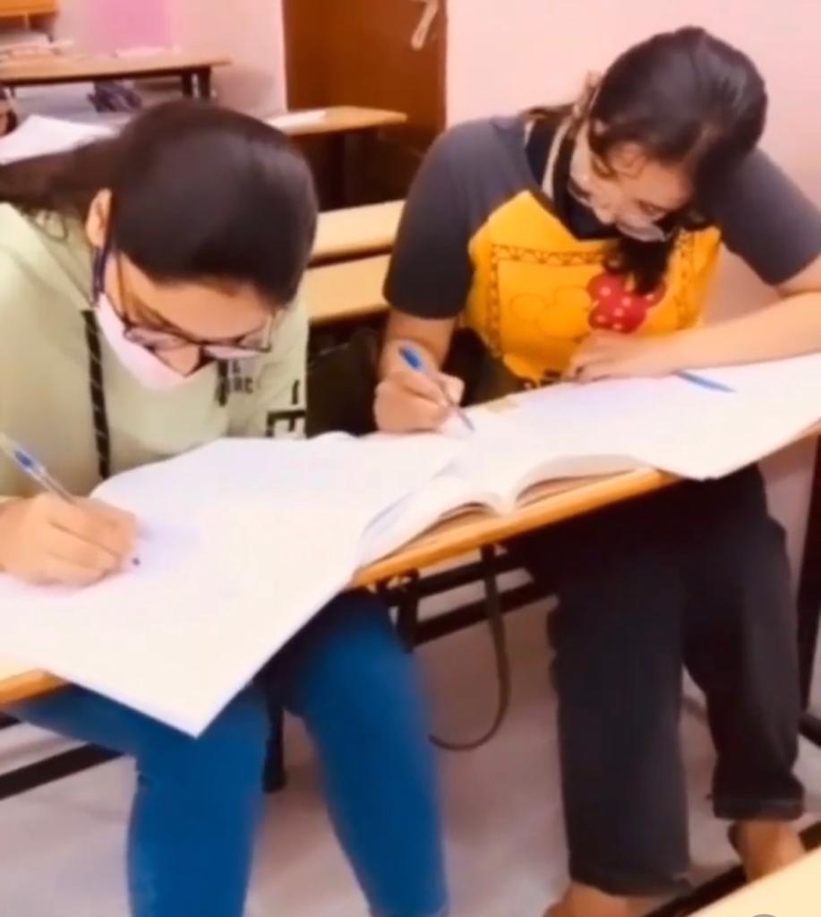

My friend and I in math class.